GRIEVANCE MECHANISM
RUFIJI-MAFIA-KILWA SEASCAPE PROJECT AREA
JULY 2020

WWF TANZANIA COUNTRY OFFICE (WWF TCO)
DAR ES SALAAM - TANZANIA

Table of Contents
1. Introduction 1
1.1. Who can submit a grievance? 1
1.2 Criteria for grievances (eligibility) 1
2. Submission of Grievances 2
2.1 How can a grievance be submitted? 2
2.2 Project Hotline Telephones and Complaint Team 3
2.3 Important information in complaint form 3
3 How WWF and WI deal with grievances? 4
3.1 Individual case management: 4

Introduction

In addition to the participatory approach, stakeholder engagement, awareness raising and transparent inclusive decision making, the grievance mechanism allows anybody who believes to be affected by any project activities or behaviour of project implementer or partners to complain at any time and through different easy to use access points. Stakeholders can raise concerns, express agreement or disagreement with certain activities, suggest changes in the project design or complain about the behaviour of persons or organizations involved in project activities. The grievance mechanism aims to build trust between the project and stakeholders and allows to adjust and improve project activities.
This document explains who can submit a grievance, where and how it can be submitted, and the internal process how WWF and Wetlands International (WI) will deal and respond to grievances. The grievance procedure is free, open and accessible to all, and grievances will be addressed in a fair and transparent manner. Data- and personal protection will be considered at all stages of the process.

Who can submit a grievance?

- Individuals and groups of people residing in or near a project site;
- Individuals and groups of people who interact with WWF or Wetlands International;
- Any individual, organisation, group or community who believes the WWF/Wetlands International project has, or is likely to, adversely affect them;
- Complaints may be presented through a representative party if the persons on whose behalf the representative is acting are identified and evidence of the representative’s authority to do so is provided in the complaint;
- Anonymous grievances will be accepted, although fact finding and resolution of the complaint might be hampered by the fact that enquiries to the complainant are not possible.
- A complainant is therefore encouraged providing an option for contacting her or him even anonymously.
- Misuse of the grievance mechanism through malicious or denigrative complaints will not be tolerated.

Criteria for grievances (eligibility)

- The complaint must be made with regard to project activities or the behaviour of project implementing staff or partners;
- The complaint must include information on the main (negative) effects;
- There must be a link between the WWF/Wetland’s International project’s action and the grounds for the complaint made and
- The complainant believes they are or will be (negatively) affected by the circumstances outlined in the complaint

2. Submission of Grievances

2.1 How can a grievance be submitted?
Complaints can be directed to WWF’s and Wetlands International’s Project Complaint Team by any of the following means:
- Orally to project staff of WWF and WI
WWF and WI field staff and designated complaint-resolution managers consisting of WWF and WI employees (see 2.2 :b), will accept complaints, provide relevant information on the process, discuss the complainants’ situations with them, and explore possible approaches for resolution processes for acknowledging the receipt of a grievance and informing the complainant about the time frame in which a response can be expected. Once a complaint has been received, it will be recorded in the complaints log or data system. The grievance managers are in-charge of receiving and recording the grievance form (Annex 2: Table 1a and Table 1b).
(b) Village elders and other respected persons in the community have been enabled to receive and forward complaints to the WWF project team or the Project Complaint Team through their traditional or customary practices. They may use traditional structure problem solving and employ local standards and criteria to guide decisions. In some communities (villages), traditional dispute resolution procedures are more acceptable than any external proposed approach. The project will respect such procedures.

(c) Grievance drop boxes: The physical addresses are shown below:

Institution/Organization | Physical address
WWF Tanzania Country Office | Plot 252, Kiko Street, Mikocheni-Dar Es Salaam
Marine Park and Reserve Unit (MPRU | P.O. Box 7565 Upanga, Dar Es Salaam
Wetlands International, Dar Es Salaam Office | C/O Foundation for Energy, Climate and Environment (FECE). Anneta Commercial Complex Block B, Makongo juu P.O.Box 6494 Dar Es Salaam
Tanzania Forest Service (TFS) Headquarters | P.O. Box 40832 Mpingo House – Chang’ombe Dar Es Salaam
Mafia Island Marine Park (MIMP) | P.O. Box 74 Mafia Island, Coast Region
Kilwa District Commissioner Office | P.O. Box 52 Kilwa – Lindi Region
Mafia Island District Commissioner Office | P.O. Box 55 Mafia Island – Coast Region
Kibiti District Commissioner Office | P.O. Box 1 Kibiti, Coast Region (Pwani)
WWF Marine Programme Kilwa Field Office | P.O. Box 160, Kilwa – Lindi Region
WWF Marine Programme Mafia Field Office | P.O. Box 23 Mafia Island, Coast Region (Pwani)
Tanzania Forest Services Agency (TFS), Kibiti Office | P.O. Box 61, Kibiti – Coast Region (Pwani)
Grievances desk/corner established at Village Liaison Committee (VLC) offices in the park (Mafia Island) | 14 Villages inside the park
Grievances and conflict resolution desk/corner established at Beach Management (BMU) offices | 30 Villages outside the Park & in CFMA areas (Kibiti, Mafia and Kilwa)
Grievances and conflict resolution desk/corner established at Village Natural Resource Committee (VNRC) offices in Rufiji Delta villages | - Villages inside the Delta area (Kibiti)

(d) Other means of receiving grievances: Grievances will be received through a letter, emails, project designed template forms, toll-free telephone call or texts, written reports and WWF TCO Websites (link).

Note that, a standard power point presentation is available for WWF and WI project staff to familiarize and use it throughout the project implementation process for awareness creation and capacity building to various stakeholders.

2.2 Project Hotline Telephones and Complaint Team
- Telephone:
During office hours grievances can be submitted via telephone directly to the Project Complaint Team.

- E-Mail address:
grievancereport@wwftz.org

- Grievance website and template forms
Available at WWF Tanzania Country Office website: https://wwf.panda.org/wwf_offices/tanzania/?364770/Grievance-Mechanism-and-forms
Annex 2: Table 1a; Table 1b: can be downloaded here). It is important to note that, the grievance form /process through Blue Action Fund (BAF) website will only be brought into the picture if/when the complainant wishes to escalate the matter to BAF.

- Project Complaint Team
- Dr. Simon Lugandu, WWF Tanzania Grievance and Conflict Manager, slugandu@wwftz.org, Mobile telephone number +255788900166
- Ms. Matrida Simfumkwe, WWF Tanzania Deputy Grievance and Conflict Manager, msimfukwe@wwftz.org, Mobile telephone number +255788900166
- Ms. Lilian Nyaega, Wetlands International Eastern Africa Programme Officer,
- lnyaega@wetlands-eafrica.org, Mobile telephone number +254 707 366 395
- In addition, WWF international provides a toll free 24/7 complaint hotline, where grievances can be submitted in English and Kiswahili. The number is: +441249661808

2.3 Important information in complaint form
The complaint should include as much as possible the following information:
- Complainant’s name and contact information (not for anonymous grievances),
- If not filed directly by the complainant, proof that those representing the affected people have authority to do so,
- The specific project or activity of concern including location and the harm that is or may be resulting from it,
- Any other relevant information or documents (e.g. date of event),
- Any actions taken so far (if any) to resolve the problem, including contact with WWF,
- Proposed solution and
- Whether confidentiality is requested (stating reason)

How WWF and WI deal with grievances?
The Grievance Resolution Process is overseen by a Project Complaint Team consisting of WWF and WI senior managers who are not directly involved in the project implementation. After receiving the grievance, the Project Complaint Team will follow the steps of individual case management as outlined below. It will ensure data- and personal protection for the complainant and the accused. It is responsible for accurate documentation of the grievance. The Project Complaint Team will decide if the grievance is covered by its mandate, or if other entities should be involved.
In the course of the individual case management the Project Complaint Team will delegate certain steps to other trusted persons, e.g. for technical fact finding etc.

3.1 Individual case management:
- Step 1 – Receiving a complaint
- Acknowledge receipt and inform the complainant about the next steps (within 5 working days after receiving the complaint)
- Assess the urgency and character of the complaint (e.g. serious allegations versus technical or political disagreement)
- Risk analysis for complainant / potential victims / and the accused (whistle blower). If needed, immediate measures will be taken (e.g. separate concerned persons of a grievance)
- Assess eligibility: The Project Complaints Team, will assess the eligibility of the complaint against the above named general criteria and WWF policies and provide a response as to the complainant whether or not it is eligible.
- Plan the process and make it transparent: If the complaint is eligible, the Project Complaints Team will come up with a plan to look into the complaints and timeframe for this process. The team will then communicate this information to the affected party within 10 business days after receiving the complaint.

- Step 2 – Fact finding and Investigation
Fact finding: The Project Complaints Team will look into the matter, with additional technical support as needed, including support from the field offices. It will verify statements from the complaint and check facts as much as possible. The Project Complaints Team will do so with utmost care for data and personal protection. The Project Complaint Team will not investigate in criminal acts. In this case they will forward the grievance, if the complainant agrees, to the responsible authority.
- Step 3 – Resolution:
Based on the results of the fact finding, the Project Complaints Team will then work with concerned parties to develop and implement an action plan and timeframe of steps required to resolve any issues identified. The team will facilitate support to further clarify, assess, and resolve issues raised as needed, including if appropriate, engaging input from outside experts and experienced officials/individuals (e.g. local opinion leaders, Chairpersons of district and regional Peace and Security Committees and Park Warden).
- Step 4 – Response:
A summary of the concern raised, actions taken, conclusions reached, follow up plan and timeframe for completion will be documented and communicated as agreed between the parties.
(a) Information / Escalation
In accordance with the nature, urgency and relevance of the grievance the Project Complaint Team will inform WWF Germany and WWF International about the complaint as soon as possible and keep them in the loop during resolution. WWF Germany will inform the Blue Action Fund as part of their regular project reporting.
The complainant has the right to escalate the grievance to the Blue Action Fund or to WWF International if they couldn’t be resolved at the project level. The respective contact information will be published and provided in the response to the grievance.
(b) Publication, Monitoring and Learning
Agreed action plans will establish a timeframe for regular process monitoring towards resolution of the complaint (see step 3 individual case management). The Project Complaints Team will coordinate the monitoring by organizing periodic checks – bringing together the concerned parties and relevant technical advisors for meetings or other communication on the status of action plans, until they are completed. WWF and WI will assess the effectiveness of this complaint resolution process on an annual basis, and identify any need for improvement regarding its project management, theory of change, stakeholder engagement process and the grievance mechanism.
(c) Non- retaliation
WWF strongly disapproves of and will not tolerate any form of retaliation against those who report concerns in good faith. Any WWF employee who engages in such retaliation will be subject to disciplinary action up to and including termination of employment. WWF will take all feasible actions to protect complainants against retaliation. Anyone who has made a report of suspicious conduct of a WWF employee and who subsequently believes he or she has been subjected to retaliation of any kind should immediately report it by the same channels as noted herein.
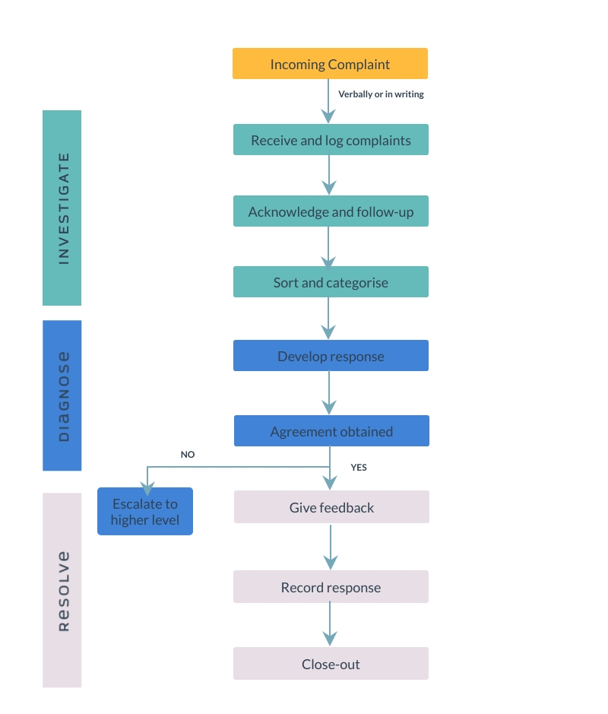
Annex 1: Flow Chart

They will use District Commissioners address
They will use District Commissioners address

