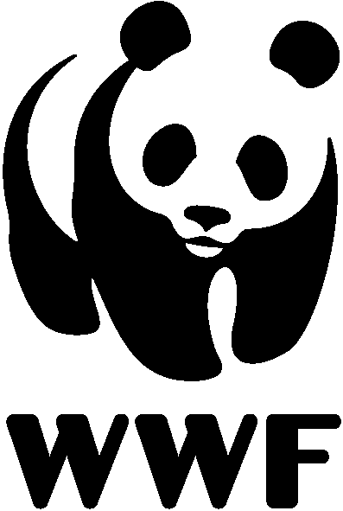

Internship Application Form
WWF International Youth Engagement Programme

Behavioral competencies for WWF assignments:
Adhere to WWF’s values, which are Courage, Integrity, Respect and Collaboration

Title of assignment you are applying for:
WWF Office:
Date of application:

Please complete all required sections with an *
1. PERSONAL INFORMATION*:
- First Name:
- Family Name:
- Date of Birth:
- Nationality:
- Gender:
2. CONTACT INFORMATION*:
- Current Address
- Permanent Address:
- Phone Number:
- Email Address:
- Current Address:
- Emergency Contact (Name and Phone):

3. LANGUAGES*: (please mention you if you are advanced or intermediate)
- Mother language:
- French:
- English:
- Other languages:
4. CURRENT STATUS*:
- Full-time/part-time student:
- Full-time/part-time worker:
- Job position:
- Employer:
- University:
- Other responsibility:
5. EDUCATIONAL BACKGROUND*:
- Highest level of education completed:
- Current educational institution (if applicable):
- Field of study/Major:
- Expected graduation date (if applicable):
- Relevant coursework:
6. RELEVANT PAID INTERNSHIP/VOLUNTEER WORK*:
- Employer:
- Period of assignment:
- Paid position/volunteer assignment/internship:
- Description of employment/assignment:
7. RELEVANT SKILLS AND EXPERIENCES*:
- List any relevant technical skills:
- Describe your experience with environmental or conservation projects:
- Have you worked or volunteered with any NGOs before? If yes, please describe:
- List any relevant certifications or training (if applicable):
8. LIFESTYLE & MOTIVATIONAL QUESTIONS*:
- What is your motivation to apply to WWF and what is it about the organization that particularly interests you? (250 words max)
- What do you think would be the most challenging aspect of being an intern with WWF in a developing nation and/or a very different culture? (250 words max)
- What do you think is the role of conservation organizations in promoting conservation and sustainability in developing nations? (150 words max)

- What do you think is the role of youth in promoting conservation and sustainability in developing nations? (250 words max)
- Describe a project or work that you have done, either in conservation or other global issues. Explain to us what you learned from this experience. (150 words max)
- How do you think this internship will contribute to your career goals? (150 words max)

- Lastly, what are your expectations from a placement with WWF?

- Have you ever raised funds for a social cause? If so, how was the experience and share your learning as a fundraiser? (100 words max)
- Do you have experience in communications? And what is your interest in creating multimedia (videos, photos, writing) to share your WWF experience?
9. PLEASE PROVIDE YOUR REFERENCES*
- Please provide contact information for two professional or academic references:
Reference 1:
- Name:
- Designation:
- Relationship to you:
- Organization:
- Email:
- Phone number:
Reference 2:
- Name:
- Designation:
- Relationship to you:
- Organization:
- Email:
- Phone number:

Additional Information
- Is there anything else you'd like to share about your qualifications or interest in WWF?
- Are there any physical limitations or medical conditions we should be aware of? (Know that this will not affect your application, we just want to be informed for us to prepare if any special support is needed for the assignment)
- How did you hear about this internship opportunity?

10. DECLARATION*:
- I certify that the information provided in this application is true and complete to the best of my knowledge.
- I understand that any false statements or omissions may disqualify me from further consideration for the internship program.
- I authorize WWF to contact the references provided to obtain information about my qualifications and experience.

Signature: ______________________ Date: ________________

Selected applicants may have to follow a medical check up before the start of the assignment.

